Flowchart

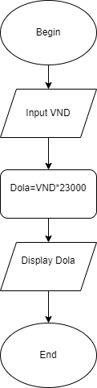 

Pseudo-code

Begin

Input VND

Dola=VND\*23000

Display Dola

End